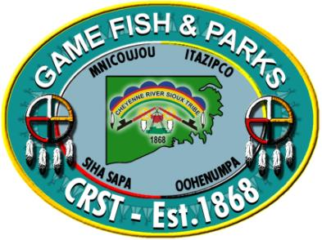
CRST Tribal Member Elk Lottery 2019

Game, Fish & Parks
PO Box 590 East Hwy 212 Eagle Butte, SD 57625
Website: www.crstgfp.com Email: gfplicense@lakotanetwork.com
Phone: (605) 964-7812
Fax: (605) 964-7811

Application DEADLINE is September 13th, 2019
General application guidelines: The Cheyenne River Sioux Tribe’s Game, Fish and Parks will be having a lottery drawing for five management bull hunts available to CRST tribal members only. Applications to enter the lottery will be $10 nonrefundable and if drawn, successful applicants will need to pay $500 to purchase their tag. If successful applicant fails to pay the $500, GFP will have a redraw for the remaining tags until all five tags are purchased. Hunts will be fully guided by GFP personnel and each successful applicant will need to schedule their hunt with CRST GFP upon the purchase of their tag. Each person is only allowed one tag and one lottery entry. All applicants must be 12 years of age or older and all applicants under the age of 18 must possess a firearms safety certificate.

Application process: Application deadline will be September 13th, 2019 and the drawing will be held on September 16th, 2019. Successful applicants must purchase their tags by September 30th, 2019 or their tag will be redrawn and awarded to another tribal member. Tribal members can apply online at https://crst.nagfa.net/online/, through this mail in application, or in person at the Cheyenne River Sioux Tribe’s Game, Fish and Parks office located on East HWY 212 in Eagle Butte.

**Reminder: License fees are not due until after the drawing on September 16th, 2019 has been done. However, a $10 nonrefundable application
fee is required when submitting the application (due September 13th, 2019).

Name:
Last First Middle Initial

Address:
RR/Box Apt#/Street

City/Town State Zip Code

DOB(MM/DD/YY): Height: Weight: Eye Color: Hair Color:
Phone: (H): (W): E-mail:

REMEMBER TO ADD THE $10 APPLICATION FEE. Total Amount Enclosed: $

A COPY OF YOUR DRIVER’S LICENSE IS REQUIRED WITH APPLICATION

MONEY ORDER/CASHIER’S CHECK PAYABLE TO: GFP ENTERPRISE ACCT
**ABSOLUTELY NO PERSONAL CHECKS WILL BE ACCEPTED**

